Comments on the Draft Law on Employment Support
General remarks
The draft requires substantial improvement, regarding both structure and content. In particular the inconsistencies in the definition of the target groups need to be resolved. It should also be discussed with the Ministry and SESA before it can be submitted to Parliament. Three aspects are of particular importance:
1. The law should not just regulate the current situation but open the way for future improvements (NSM, ALMP, SESA budget, unemployment insurance) and institutional development of SESA.
2. Current malpractice should not be codified (Article 33) but abolished.
3. The Law should stipulate cooperation in the field of information systems and support the integration of all data sets relevant for projections of both supply and demand side of the labour market.
1. Formal aspects
The title of the law should be reconsidered. ‘Law on Employment Promotion’ would be more comprehensive than ‘Employment Support’ and also more appropriate. According to the Eurostat 2013 classification of LM interventions the activities carried out by SESA fall under the categories ‘Services’ and ‘Measures’, whilst ‘Support’ primarily refers to unemployment benefits which currently do not exist in Georgia.
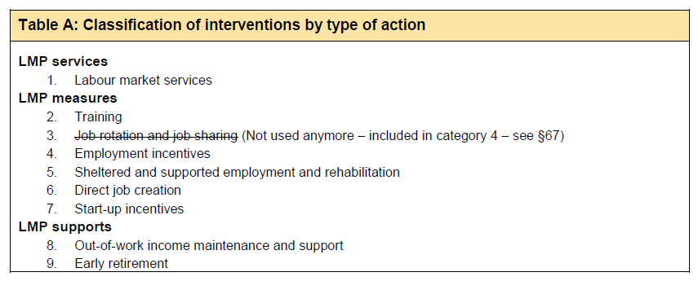
Eurostat (2013), §34, p. 13
Some formulations in the draft are very detailed (e.g. listing specific job positions of SESA in Article 2, Articles 23 – 25 on profiling, evaluation of employability and individual career planning) and it should be considered to shift them to subordinate legislation or to internal regulations of SESA. Thus it could be avoided that minor or ad-hoc adjustments - like eliminating or creating new types of SESA positions – would require a change of the law by parliament.
Article 2: Definitions
Some important definitions are missing. A definition of Employment Policy, for instance, would be more useful than a definition of employment support event in Article 2, c) or q) active job seeking.
Unnecessary definitions should be eliminated from Article 2. This applies in particular to those definitions which do not show up later in the subsequent chapters of the draft like the titles of some SESA positions: 2d) employment consultant, 2i) career guidance specialist, 2m) employment support consultant. What is needed in the law is the description of SESA functions, but not job titles.
Short-term vet courses (Article 2, k) would be better listed in the overall context of ALMP measures.
Regarding the definition of target groups, Article 2 should be examined regarding their comprehensiveness and consistency.
- r) job seeker: unemployed, or employed, who is actively seeking for a job, can start working for upcoming two weeks and is registered in State Employment Support Agency’s base for job seekers.
- u) unemployed: Person over 16, who is able to work until pension age and doesn’t have paid job for registration period.
- The definition of vulnerable groups in Article 2, l) could be improved: group of individuals, who due to certain physical, psychological or social characteristics experience a higher risk of poverty and social exclusion than the general population.
Article 4: Legal grounds of employment support
As already mentioned, promotion would be a more suitable term than support.
It could be considered to mention explicitly Articles 1 and 2 of the ILO Convention 88, which stipulate that the essential duty of the employment service shall be to ensure, in co-operation where necessary with other public and private bodies concerned, the best possible organisation of the employment market as an integral part of the national programme for the achievement and maintenance of full employment and the development and use of productive resources.
2. Definition of the target groups
The right of all citizens to have access to SESA services should be explicitly stated in a separate Article. This is of utmost importance for the population of remote areas referred to in Article 5, 2.
The law should more clearly define the target groups. At the moment it targets almost exclusively job seekers and unemployed, while employers and vacancies play a very limited role in the draft. The mediation function of PES, however, requires from them to handle both sides of the labour market equivalently.
Job seekers and unemployed
The challenge is that these groups are overlapping, since a job seeker can be unemployed, but an employed person can likewise be looking for a job, which may lead to confusion and lack of clarity.
As mentioned above, the draft law specifies that a job seeker is someone unemployed or employed, who is actively seeking for a job and can start working within the next 2 weeks (Article 2 r and Explanatory Note a.c). Furthermore, it defines “unemployed” as “someone aged 16+ until the pension age, who has no job at the time of registration” Article 2u).
The Explanatory Note, however, specifies that unemployed, for the purposes of this law, is a person who has no job and at the same time is not looking for a job. (Explanatory Note, section a.c) This definition of the unemployed is not aligned with the standard international definition which implies that an unemployed person should be looking for a job. Job seekers not looking for a job – a contradiction in itself – should not be registered in the WorkNet, but seen as clients of the SSA instead of SESA.
The basic issue is that the draft law divides the two groups along their job search behaviour (whether they are looking for job or not) and not in accordance with their actual employment status, which would be the right approach.
The 4 groups of job seekers previously applied by the SSA and not yet revised could easily be redefined in a suitable way by clearly distinguishing between employed and unemployed job seekers. It should further be taken into account that persons with disabilities (PwD) are only a subset of vulnerable groups. Finally, PwD who can work should be distinguished from those who are not able to work and, therefore, should not be registered as job seekers in the WorkNet as it is currently the practice.
The following diagram gives a rough overview of the different groups of job seekers.
Job-Seekers
(1)
Employed
(2)
Unemployed
(2.1)
Easy to place
(2.3)
Vulnerable
groups

(2.2)
Need for
additional
support

Persons with Disabili-ties
Work-place at risk

- Employed job seekers: They coincide with Group 1: Employed individuals who are looking for a new job. (Re-)Training measures could be applied for those whose work place is at risk.
- Unemployed job seekers: They comprise Groups 2 – 4 in the current classification. These groups qualify for ALMP measures. The emphasis, however, should be on groups (2.2) and (2.3).
(2.1) Unemployed, who posess certain skills and experience and are easy to employ. ALMP measures for skills in short supply are applicable for this group, especially training and retraining for specific workplaces. However, they should primarily be offered mediation and placement in ordinary jobs, provided there are enough vacancies registered.
(2.2) Unemployed, who need additional support to find employment. These are people who need to improve their skills, as well as some long-term unemployed (LTU) persons. Various ALMP measures might be suitable, but the emphasis would be on training and wage subsidised jobs, especially for young people who lack work experience.
(2.3) Vulnerable groups. Among them, but not exclusively, are persons with disabilities. Most LTU as well as discouraged or inactive persons fall into this group. They belong to the pool of “hard to employ” individuals, that require significant support and active involvement from the SESA. All types of ALMP measures might be suitable, with sheltered workplaces especially for PwD (Eurostat 2013, §77, §§ 90 – 102).
Vulnerable groups also comprise persons who are not able to work. They are not a target group of employment legislation. This is of relevance with respect to Article 33 of the draft law. (See below.)
Employers
The Employment Law should not only focus on helping the citizens to get a decent job. It should also support the enterprises being able to recruit the qualified labour to fill their vacancies. In the short term via relevant Active Employment Measures like short term courses. PES has two objectives:
- Ensure that there are no bottlenecks due to lack of qualified labour (enterprises)
- Reduce unemployment – in particular long term unemployment (job-seekers)
Enterprise services (visits, information, identification of vacancies and expectations to the future) are consequently as important as services to the job-seekers. Therefore, working with employers and the acquisition of vacancies should be much more emphasised and be treated on an equal footing with the placement of job seekers.
3. Social Assistance recipients
Labour market policy needs to bridge economic and social policy, but both aspects should be given equal attention. However, the regulation (Article 33) that all recipients of Targeted Social Assistance (TSA) are obliged to register as job seekers in the WorkNet needs to be deleted. The current malpractice should not be perpetuated by confirming it in a new law. This would be a big obstacle to be removed again.
The definitions in the draft do not clearly separate recipients of TSA who are not capable of working from unemployed job seekers. Targeted Social Assistance (TSA) recipients feature as a special target group, however, it is not clear how they would benefit from the enactment of the new law. Article 33 defines that TSA recipients must register as job seekers and that SESA will do everything to increase their motivation to work. Young TSA recipients are also considered as a target group for “subsidized employment” measure.
All of these stipulations in the draft do not seem to be addressing the main concern. Namely, the given approach implies that all TSA recipients are “able to work”. If this target group is taken into account seriously as they should be, the law should first of all provide a definition of “able to work” and then split the group of TSA recipients accordingly. Only those who will be considered able to work should then be obliged to register as job seekers.
Allowances for unemployed job seekers must be separated from social assistance for persons who are not able to work. The fields of competence, therefore, should be clearly split: The SSA is in charge of social policy, whilst SESA is in charge of employment policy; and only people able to work can be regarded as job seekers.
4. SESA budget for unemployment allowances and LMP measures
There should be a possibility for a supports budget run by SESA to finance unemployment allowances. Social assistance financed by the SSA budget and financial support to unemployed persons should not be confused.
The introduction of a budget administered by the SESA to finance unemployment allowances instead of TSA would pave the way to the introduction of a future regular system of unemployment insurance. The SESA should also administer the budget for financing LMP measures.
The Law should open the path for the introduction of such a system. Introducing a budget managed by SESA could be the first step in this direction. Even if for the time being there are no financial means allocated for this purpose, the law should open up the possibility of establishing such a system in the future instead of codifying the current malpractice.
5. Employment Policy and Active Labour Market Policy
There should be some definition of Employment Policy in the law and how ALMP fits into this. Generally speaking, Employment Policy is the overarching concept that aims to increase employment, whilst ALMP measures are primarily designed to reduce unemployment.
The Law could also mention the European Employment Guidelines as a reference for the overall non-compulsory orientation of Employment Policy in Georgia. The current Guidelines from 26.02.2020 are:
- Guideline 5: Boosting the demand for labour
- Guideline 6: Enhancing labour supply and improving access to employment, skills and competences
- Guideline 7: Enhancing the functioning of labour markets and the effectiveness of social dialogue
- Guideline 8: Promoting equal opportunities for all, fostering social inclusion and fighting poverty
Given the limited resources it may be advisable to focus the activities of SESA on the placement of unemployed in the true sense of this concept which includes working closely with the employers to recruit suitable applicants for their vacancies. This is a matter of priorities: rather than supporting employed people moving to better jobs, those currently outside the labour market should be brought back to work. The Employment Law addresses this point, while the mobility between positions is a subject of general labour regulation/legislation in the country.
Nevertheless, if SESA assists one employed job seeker finding a better job, this can help an unemployed job seeker, if it generates a vacancy at the lower level of the job hierarchy. Pushing from the bottom should be combined with a lifting from the top strategy, e.g. by focusing primarily on LTU to replace the employed jobseeker in his/her old job.
Active Labour Market Policy
LMP interventions are distinguished from other general employment policy interventions in that they act selectively to favour particular groups in the labour market. Three main target groups are recognised: unemployed, employed at risk and inactive. The primary target groups in most countries are those people who are registered as unemployed by Public Employment Services (PES) or who are currently employed but at risk of involuntary job loss due to difficult economic circumstances for their employer.
Different types of ALMP measures are mentioned in the draft, but not in a systematic way. It would be useful to mention all possible types of measures in context under Chapter IV - Employment Support Activities. The list should be concise but comprehensive, covering not only the current measures but also enable the introduction of additional future measures. It is recommended that the description be line with the Eurostat 2013 classification as given below. However, it is not proposed to take this in full length into the law.
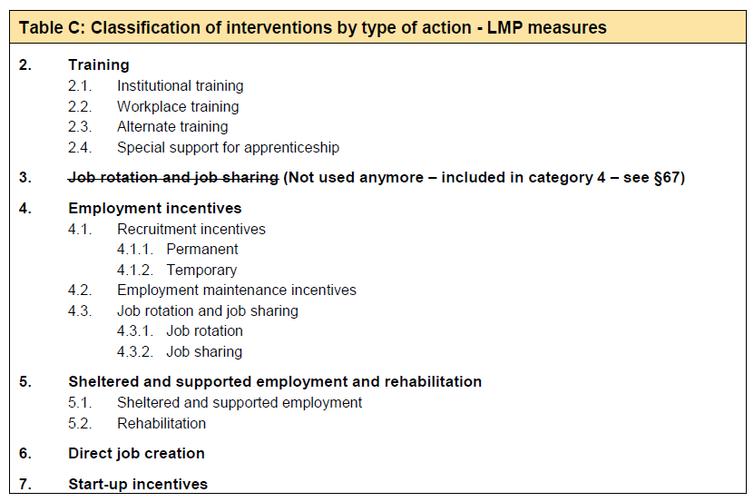
Eurostat (2013), p. 15. Details in Section 3.2, §§ 52- 114.
Motivation
The law speaks repeatedly about “motivating” the job seekers and unemployed to take up jobs. However, it is unclear how this would be achieved. As it is known from several years of SSA operation motivation is a key problem – unemployed often do not wish to attend lengthy training and counselling sessions, coming back for a next counselling session is a challenge. In Austrian/German cases, to which this law refers, this is solved by using unemployment benefits to the unemployed. Clients are obliged to follow the “rules” of the employment agency, otherwise they risk deductions or even loosing entitlement to the support. In Georgian case job seekers do not risk any sanctions.
Motivation of unemployed is mentioned in Articles 2, 9, 18, 30 and 33. Article 31 mentions motivation of employers. It is further emphasised repeatedly in the Explanatory Note, e.g. under a.c) Main idea of the law.
6. Private Employment Agencies
The law completely overlooks the need to regulate the operation of “recruitment agencies”, which in reality represent “Private Employment Agencies”. As Georgia is a signatory to ILO convention 181 on Private Employment Agencies the Law on Employment should not avoid this topic. Currently, it only specifies that other entities can carry out “Employment Services” is the state considers it relevant. This seems to be a rather restrictive approach to me. The department of labour carried out a study of “recruitment agencies” in Georgia few years ago. The results should be consulted in defining the regulatory framework for these agencies.

Eurostat (2013), Labour Market Policy Statistics. Methodology 2013 https://ec.europa.eu/eurostat/documents/3859598/5935673/KS-GQ-13-002-EN.PDF
Groups that experience a higher risk of poverty and social exclusion than the general population … facing difficulties that can lead to further social exclusion, such as low levels of education and unemployment or underemployment. https://www.eqavet.eu/eu-quality-assurance/glossary/vulnerable-group
https://eur-lex.europa.eu/legal-content/EN/TXT/?uri=CELEX:52020PC0070
Eurostat (2013), p. 5

